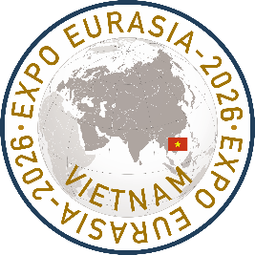
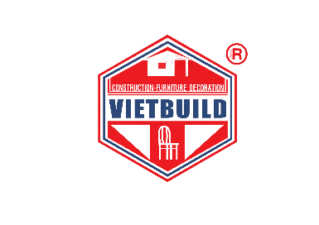

From June 24 to 28, 2026, the Seventh International Industrial Exhibition and Business Forum “EXPO EURASIA VIETNAM 2026” will take place at Sky Expo Exhibition & Convention Center in Ho Chi Minh City, Socialist Republic of Vietnam, as part of the largest international exhibition VIETBUILD 2026.
The annual international exhibition VIETBUILD brings together more than 200,000 participants and visitors from over 50 countries across an exhibition area of 42,000 square meters. The organizer of participation for companies from the CIS countries is JSC Zarubezh-Expo.
A similar exhibition, EXPO EURASIA VIETNAM 2025, was held with great success in 2025, confirming its status as a key industry platform in the region. The event demonstrated high attendance, active business engagement among participants, and significant interest from industrial enterprises and investors.
EXPO EURASIA VIETNAM is an effective business platform for showcasing the latest technological achievements, establishing new business contacts, strengthening positions in international markets, and expanding sales geography. The exhibition is supported by the Ministry of Foreign Affairs of the Russian Federation, the Ministry of Industry and Trade of the Russian Federation, the Ministry of Construction of the Russian Federation, the Ministry of Transport of the Russian Federation, the Ministry of Energy of the Russian Federation, the Chamber of Commerce and Industry of the Russian Federation, the CIS Business Center, the International Congress of Industrialists and Entrepreneurs (ICIE), the Ministry of Construction of Vietnam, and the Ministry of Industry and Trade of Vietnam, with participation from leading federal and industry-specific media of Russia and Vietnam.
The business program of the exhibition will feature an international business forum, thematic round tables, presentations by companies and regions, and a dedicated B2B matchmaking program organized for each participant.
EXPO EURASIA VIETNAM 2026 has been included in the Consolidated Plan of Participation of the Ministry of Industry and Trade of the Russian Federation in international exhibition and congress events held abroad in 2026, pursuant to Order No. 736 dated February 19, 2026.
Participants include Russian regions, industrial enterprises, representatives of city and regional administrations from Russia and CIS countries, representatives of ministries and government agencies, as well as executives and representatives of state-owned and private companies and corporations from Vietnam, China, Laos, Indonesia, Thailand, other Southeast Asian countries, Europe, and the Americas.
The thematic sections of the exhibition include mechanical engineering, metallurgy, metalworking and metal structures, construction and architecture, building materials, equipment and construction machinery, information and communication technologies, energy and electrical engineering, lighting engineering and electro-optics, transport and logistics, forestry and wood processing, mining industry, chemical industry, robotics, environmental protection and energy efficiency, water treatment and purification, waste recycling, building engineering systems and facility management, household appliances, furniture, interior design and home products, education and science.
Visitor registration is available at: www.ExpoEurasia.org
Registration link: https://expoeurasia.org/eev2026_program
ORGANIZING COMMITTEE
JSC Zarubezh-Expo
Tel.: +7 (495) 721-32-36
E-mail: info@zarubezhexpo.ru Websites: www.zarubezhexpo.ru www.ExpoEurasia.org

