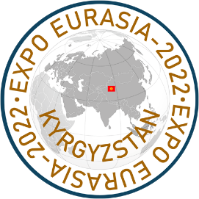

1ST INTERNATIONAL
INDUSTRIAL EXHIBITION
EXPO EURASIA - 2022 KYRGYZSTAN
and
BISHKEK BUSINESS FORUM
Bishkek, the Kyrgyz Republic

International Industrial Exhibition EXPO EURASIA – 2022 KYRGYZSTAN and Bishkek Business Forum will be held June 21-23, 2022 in the AYU-GRAND Trade and Exhibition Center (2 Chokana Valikhanova St., Bishkek). The events will be held in the traditional face-to-face format as well as online on the virtual platform.
The forthcoming exhibition is aimed to promote the expansion of trade and economic cooperation of the EAEU countries, as well as Uzbekistan, the People’s Republic of China and other.
The expositions will feature innovative products and developments in all areas of industry. The business program includes a business forum, round tables on key sectors of the economy attended by representatives of government institutions and business circles of Central Asia. An individual Match Making program is provided for each exhibitor, which includes searching and inviting target visitors from among institutions and enterprises of the Kyrgyz Republic, which cooperation is of commercial interest, as well as visiting objects of interest.
Over 20 years the Organizing Committee has been organizing and holding congress and exhibition events in different countries of the world. In total, they have been attended by over 30 thousand companies from over 20 countries, which have signed lucrative export-import contracts.
The organizers are convinced that EURASIAN-EXPO KYRGYZSTAN 2022 and Eurasian Business Forum will make a significant contribution to expansion of international economic relations and enhancement of export potential of companies and regions.

We invite you to take an active part in the international exhibition EXPO EURASIA – 2022 KYRGYZSTAN and the Business Forum

E-mail: info@expoeurasia.org
Registration of guests and participants on the www.expoeurasia.org online exhibition platform

