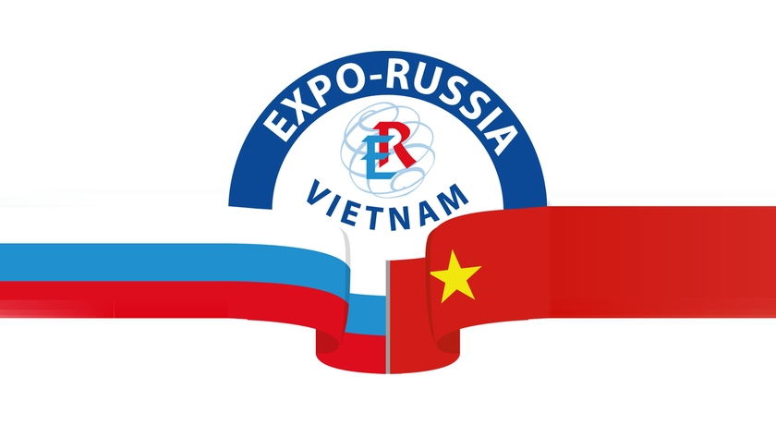
With the encouragement of the government RF and SRV
2019 – Cross Year Vietnam and Russia

BUSINESS PROGRAM
OF THE 3rd INTERNATIONAL INDUSTRIAL EXHIBITION EXPO-RUSSIA VIETNAM 2019
OF THE 3rd VIETNAM-RUSSIAN INTERREGIONAL BUSINESS FORUM
November 14 - 16, 2019
National Exhibition Construction Center – NECC,
01 Do Duc Duc Me Tri, Nam Tu Liem, HANOI

November 12, Tuesday

10 a.m. Exhibition and business forum opening press-conference
Venue: Vietnam Chamber of Commerce and Industry, No 9 Dao Duy Anh Str., Ha Noi

November 14, Thursday
09:00 a.m. – 06:00 p.m. Work of the exhibition, B2B meetings
10:00 - 10:15 a.m. Opening of the 3rd Vietnam-Russian business forum
Welcome speeches of officials and organizers
10:15 - 12:00 Business Forum
Lunch
14:00 - 14:30 a.m. EXPO-RUSSIA VIETNAM 2019 official opening ceremony
14:30 - 15:30 p.m. Exhibition area tour for officials and honorary guests
Coffee break
03:30 - 05:30 p.m. Round Table on Cooperation in Medicine and Healthcare

November 15, Friday
09:00 a.m. – 06:00 p.m. Work of the exhibition, B2B meetings
09:30 a.m – 11:30 a.m. Round Table on Cooperation in the field of Construction and Architecture
Lunch
02.00 p.m. – 03:30 p.m. Round Table on Cooperation in Agriculture and Food industry
03:30 p.m. - 04:30 p.m. Round Table on Cooperation in Energy and Industry sectors

November 16, Saturday
09:00 a.m. - 05:00 a.m. Work of the exhibition
09:00 a.m. - 03:00 p.m. B2B meetings
03:00 p.m. Ceremonial delivery of diplomas

Organizers of EXPO-RUSSIA VIETNAM and business forum:

Zarubezh-Expo JSC  Tel.: +7 (495) 721-32-36  info@zarubezhexpo.ru  www.zarubezhexpo.ru | Vietnam Chamber of Commerce and Industry  Tel: +84 904112244  Fax: +84 (24) 35742020  trangttt@vcci.com.vn  http://vcci.com.vn

